Information for Parents ~ Gwybodaeth i rieni

A warm welcome to 2E

Weekly timetable

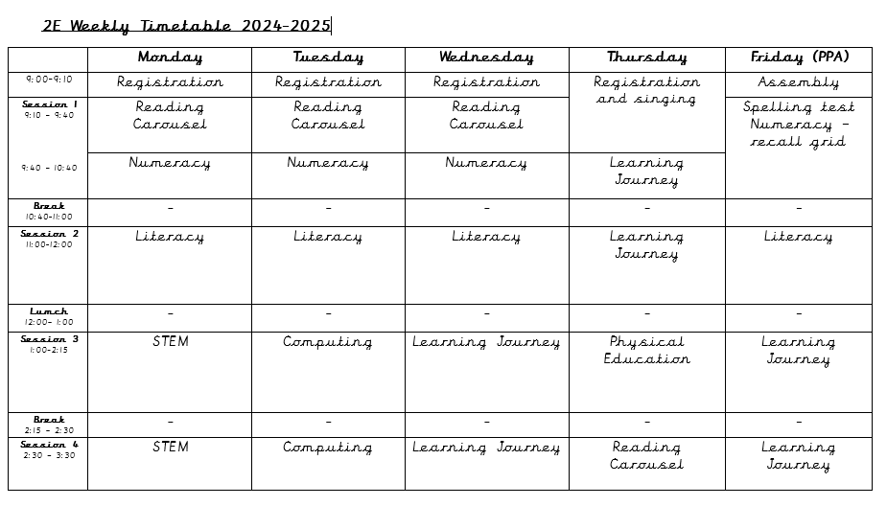

Here is an overview of the 2E weekly timetable. We will try our utmost to follow the timetable as closely as possible but there will be occasional changes.

Mrs Owen, Mrs Cole Jones and Miss Griffiths will teach the class on Thursday mornings. They will be responsible for teaching lessons and tasks within the Learning Journey Curriculum for Wales.

Reading books and the spelling process.

This year we will continue with our spelling homework from last year. The scheme makes use of thematic words key words, and a spelling scheme to correct misconceptions and help to close any gaps within spelling abilities. The word list will be shared on Friday using 'Google Classrooms' and the spelling reviewing sessions will be held on the following Friday. Contact the school if you would like to receive the list of spelling words on paper rather than 'Google Classrooms.'

Reading books will be sent home on specific days to accompany the pupils' reading timetable. From now on teachers will note comments about your child's reading in the reading record kept on Google Classrooms. We kindly ask that you to continue to read regularly with your child at home and continue to note comments about your child's reading in the reading record. I will try my best to look at these during the reading session and respond to any comments as appropriate.

Big Maths

This year, we will continue with the ‘Big Maths’ programme. We will use the programme as a resource within the classroom to review number facts and strengthen mathematical strategies and methods. There will be no timing, testing or sheets delivered home as done so previously. Instead, the focus will be on using the resources to review, re-call and reinforce Mathematical knowledge and methods in a fun and safe environment where misconceptions and mistakes are celebrated and treated as essential learning points.

Physical Education lessons

Physical Education lessons will be on a Thursday. Your child will need to wear their P.E. kit to school on the day and will remain in their P.E. kit for the rest of the day.

Homework

Optional thematic homework on Google Classrooms to be completed within the half term.

Spelling words are shared on Friday and the revision session will be held on the following Friday.

Reading – Please continue to read regularly with your child and write any relevant comments in the reading record.

Extra-curricular clubs

Extra-curricular clubs will recommence on 25/9/23. More information will follow in Mrs Sharkey’s weekly newsletter.

Theme

Autumn Term Theme – Belonging.

If you have any useful resources the children are very welcome to bring them into school.

Remember that we have an open-door policy in the school. Please come and see me if you have any concerns.

Mr G Williams