**Saving work to your HWB folder**

Log on to your HWB account.

Click Just2easy

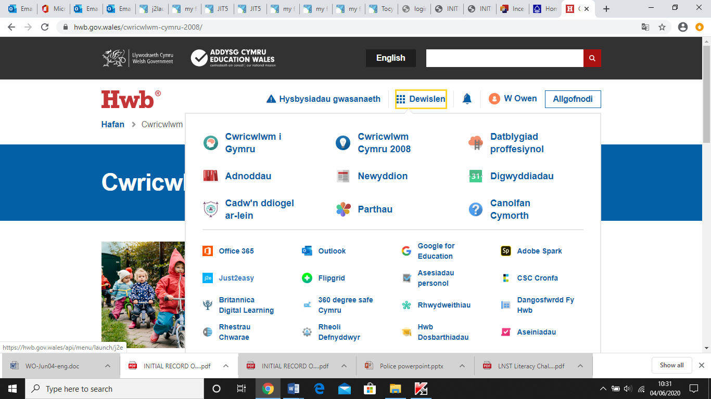

Click on My Files

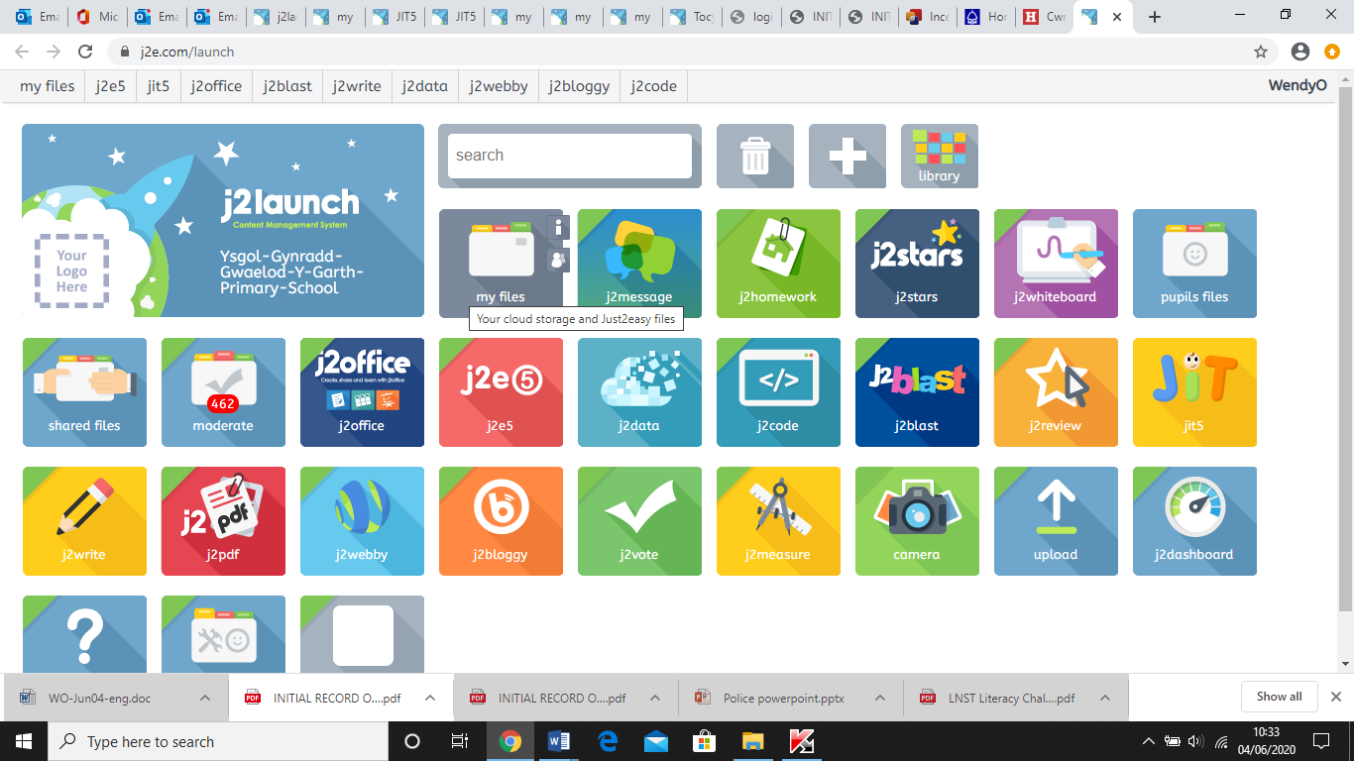

Your page should show the work you have in your folder

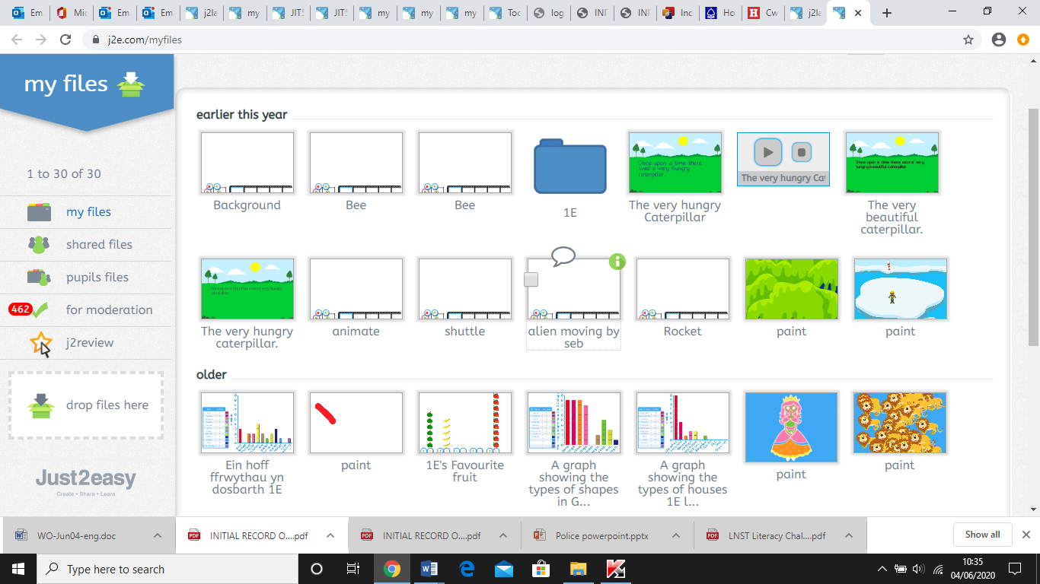

Work you create and save in JIT will automatically save here. But you can also drag and drop other files from your computer.

Keep your page open but also open your documents folder or wherever you have saved other work.

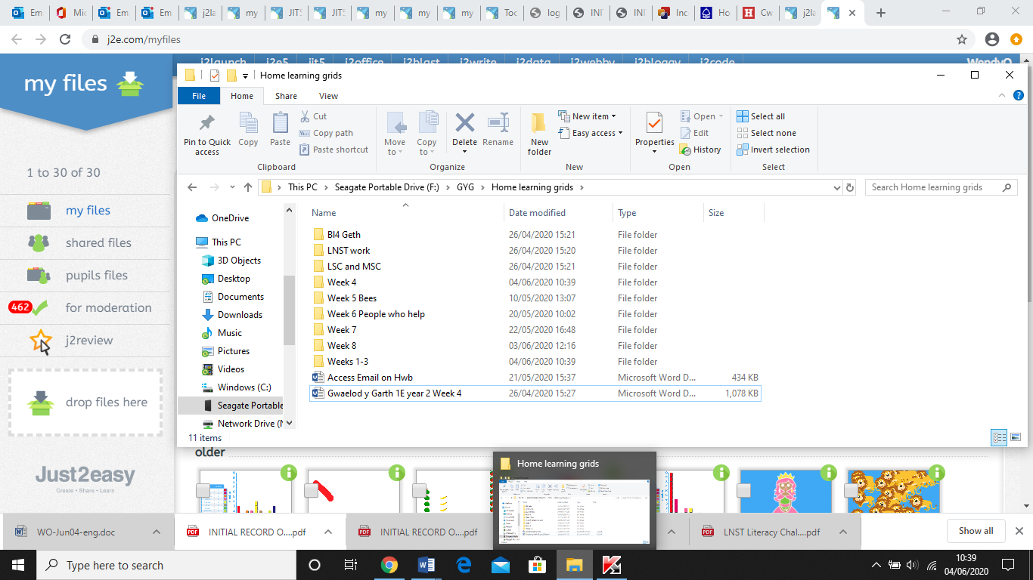

Choose the file you want then drag and drop to the ‘drop files here’ box.

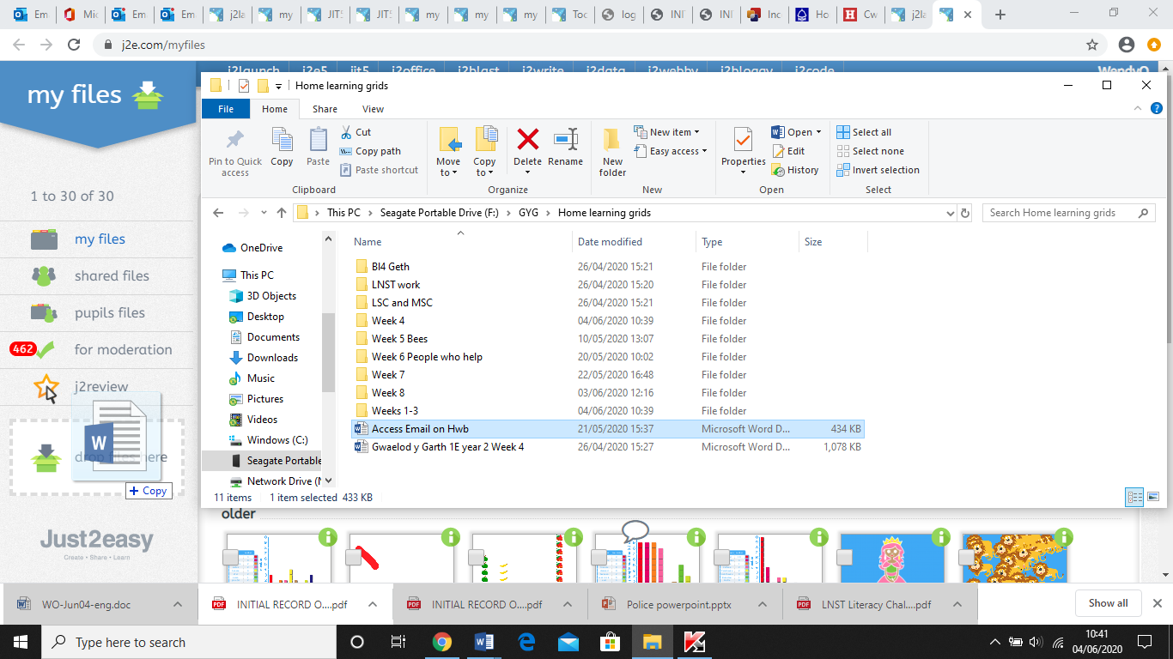

Then drop and your file should now show in your folder.

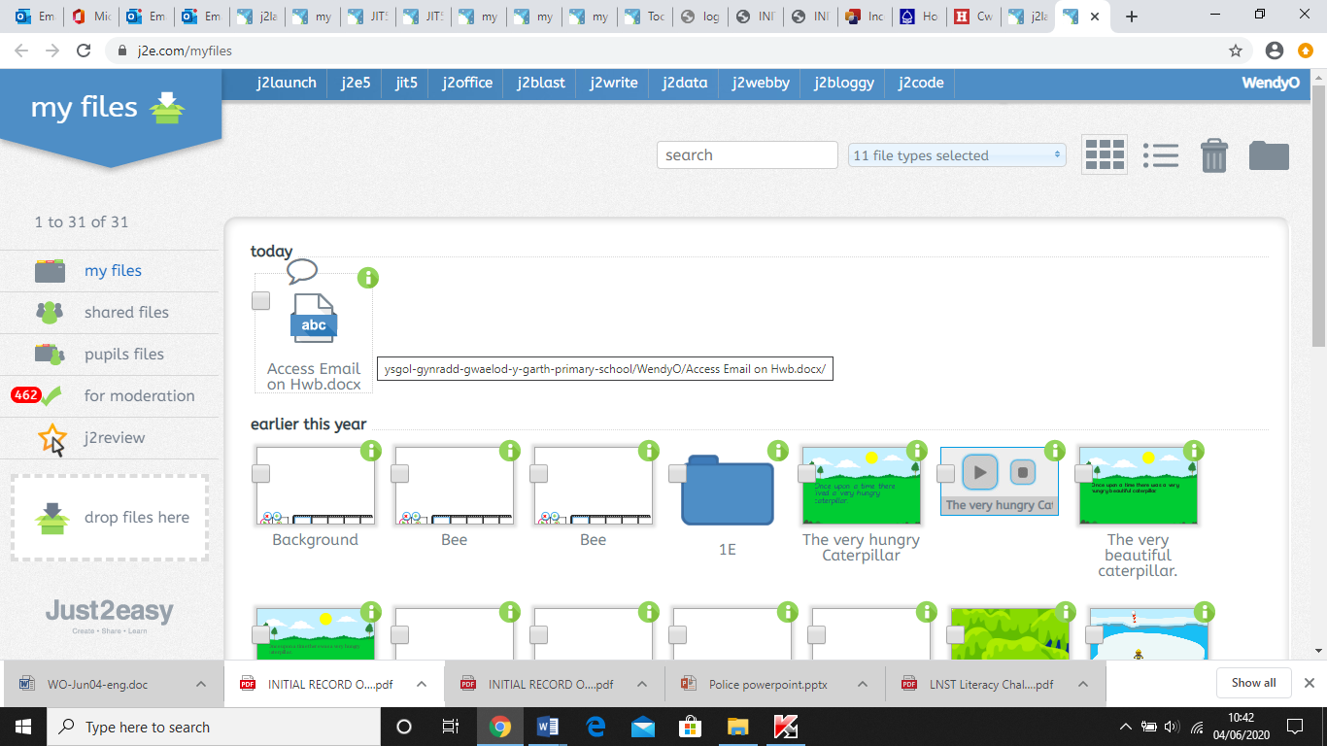

If you hover over the file you should see a speech bubble above your work. We can communicate through this by a text message, recording our voices or video.

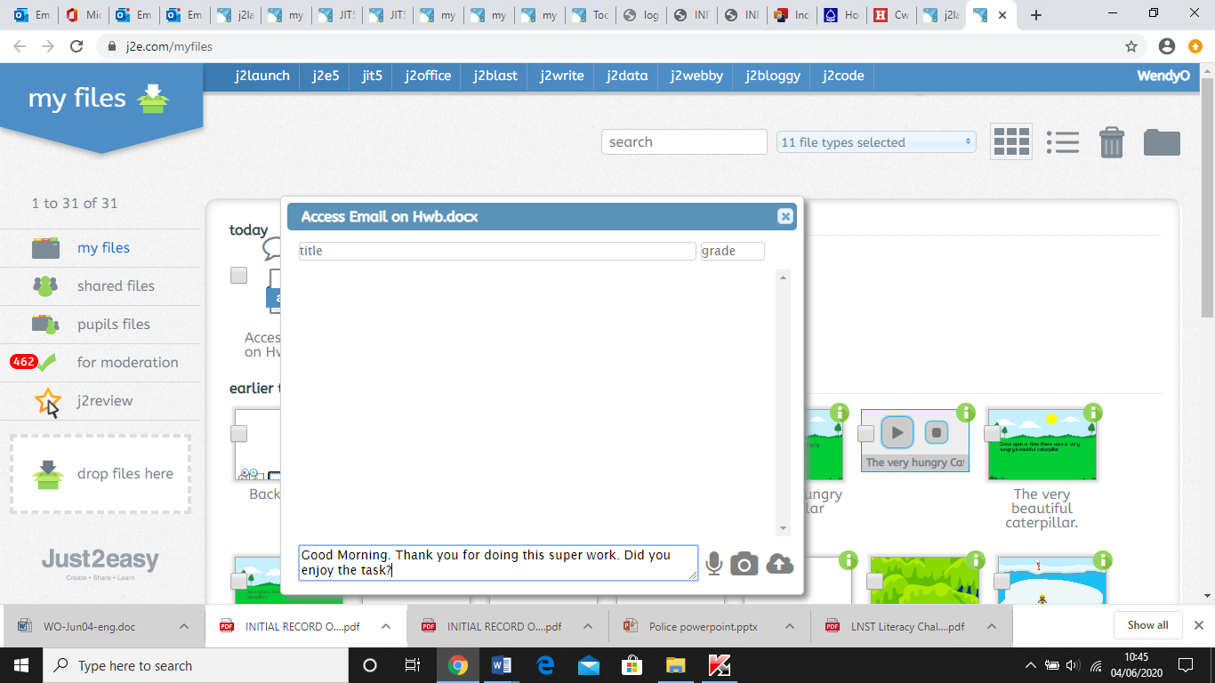

Or

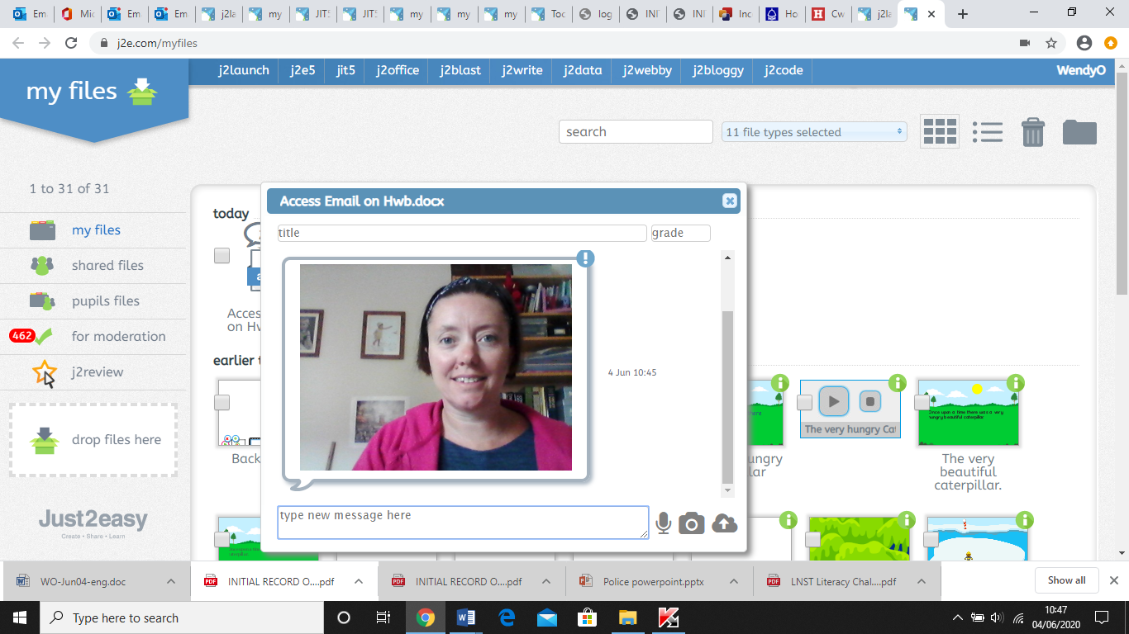

Or show me other work

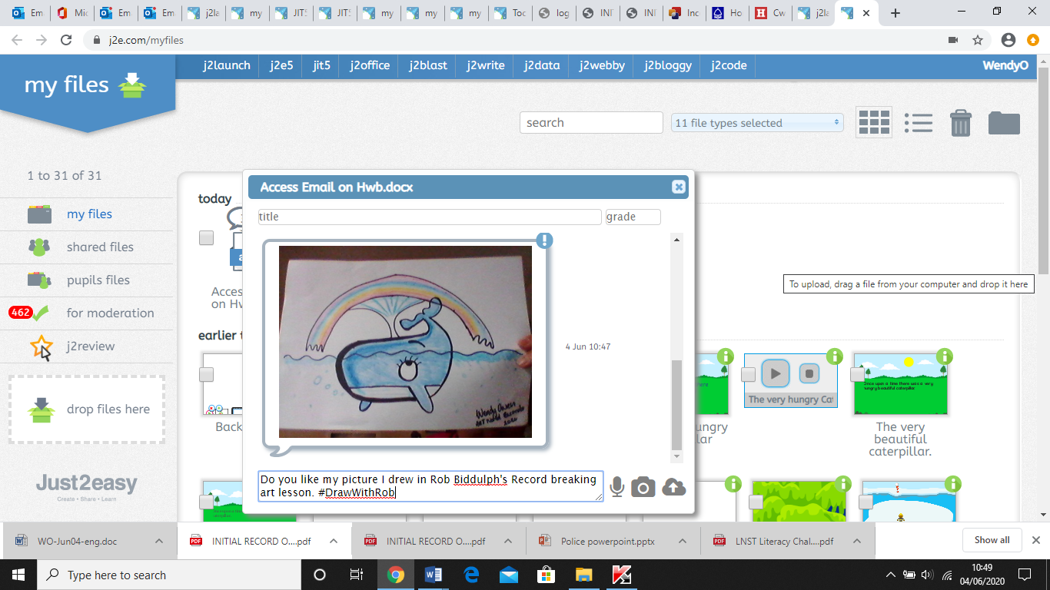

Hope this helps and I look forward to seeing your work and hearing from you soon.

Take care

From Mrs Owen